WIA/WIB2003: Inferential Statistic
T-test [ANSWER]

Use empsat.sav to answer all the questions.

- What is the frequency for the number of hours worked for the employees?

How many hours a week, on average, does your employer expect you to work?
 |  | Frequency | Percent | Valid Percent | Cumulative Percent
Valid | 35 hours or less/week | 75 | 5.1 | 5.1 | 5.1
Valid | 36 to 40 hours/week | 738 | 50.5 | 50.6 | 55.8
Valid | 41 to 50 hours/week | 568 | 38.9 | 39.0 | 94.7
Valid | 51 or more hours/week | 77 | 5.3 | 5.3 | 100.0
Valid | Total | 1458 | 99.9 | 100.0
Missing | System | 2 | .1
Total |  | 1460 | 100.0

- Draw any chart to show how long the employees have worked for the employer.
Explain.

How long have you worked for this employer?
 |  | Frequency | Percent | Valid Percent | Cumulative Percent
Valid | Less than one year | 272 | 18.6 | 18.7 | 18.7
Valid | 1 to 3 years | 439 | 30.1 | 30.2 | 48.9
Valid | 4 to 6 years | 270 | 18.5 | 18.6 | 67.4
Valid | 7 or more years | 474 | 32.5 | 32.6 | 100.0
Valid | Total | 1455 | 99.7 | 100.0
Missing | System | 5 | .3
Total |  | 1460 | 100.0

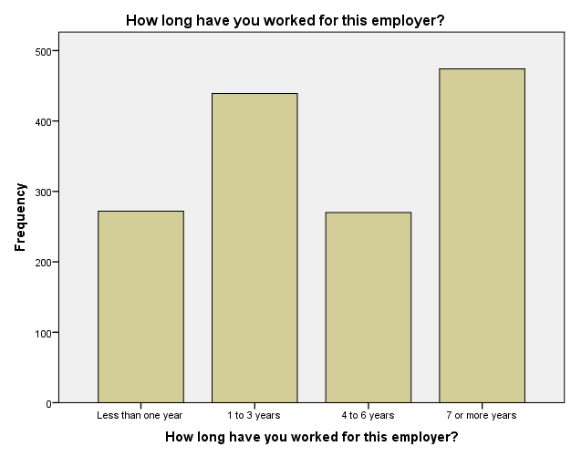

- Provide the Mean and SD for the statements below. Based on your results, what can you conclude? Write a short paragraph of your conclusion to be presented to your boss.

I am satisfied with communications between management and employees.

I am challenged and interested in my work.
My opinions are listened to and valued.
The senior management team offers leadership I can trust.
The company culture promotes ethical behavior.

- Is there a significant gender differences for the overall satisfaction of the job? Write the hypotheses and then test them with an appropriate test. Provide all the necessary values.

H-null = There is no significant gender differences for the overall satisfaction of the job
H-Alternative = There is significant gender differences for the overall satisfaction of the job

F = 0.000
Significant value = 0.991

0.991 > p-value = accept null hypothesis
Hence, there is no significant gender differences

- Perform the same test as (3) above, for the questions below. What is your conclusion?

H-null = There is no significant gender differences for all ….

- How satisfied are you with the flexibility you have to adjust your work schedule to accommodate your personal and family needs?

F = 0.198
Sig. = 0.656

Accept null hypothesis

- How satisfied are you with the total compensation (salary and benefits) that you receive at your company?

F = 0.055
Sig. = 0.814

Accept null hypothesis

- How do you feel your compensation (base pay, bonuses, benefits package) compares to others in similar positions at similar companies?

F = 8.117
Sig. = 0.004

Reject null hypothesis
There is significant gender differences for …

- Perform a test to see if there is a difference between those 18 – 24 and more than 55 when it comes to their overall job satisfaction.

F = 1.655
Sig. = 0.200

Reject null hypothesis
There is significant differences between these two groups to their overall job satisfaction

- Do the same for the statements in (5) for the same age group in (6).

